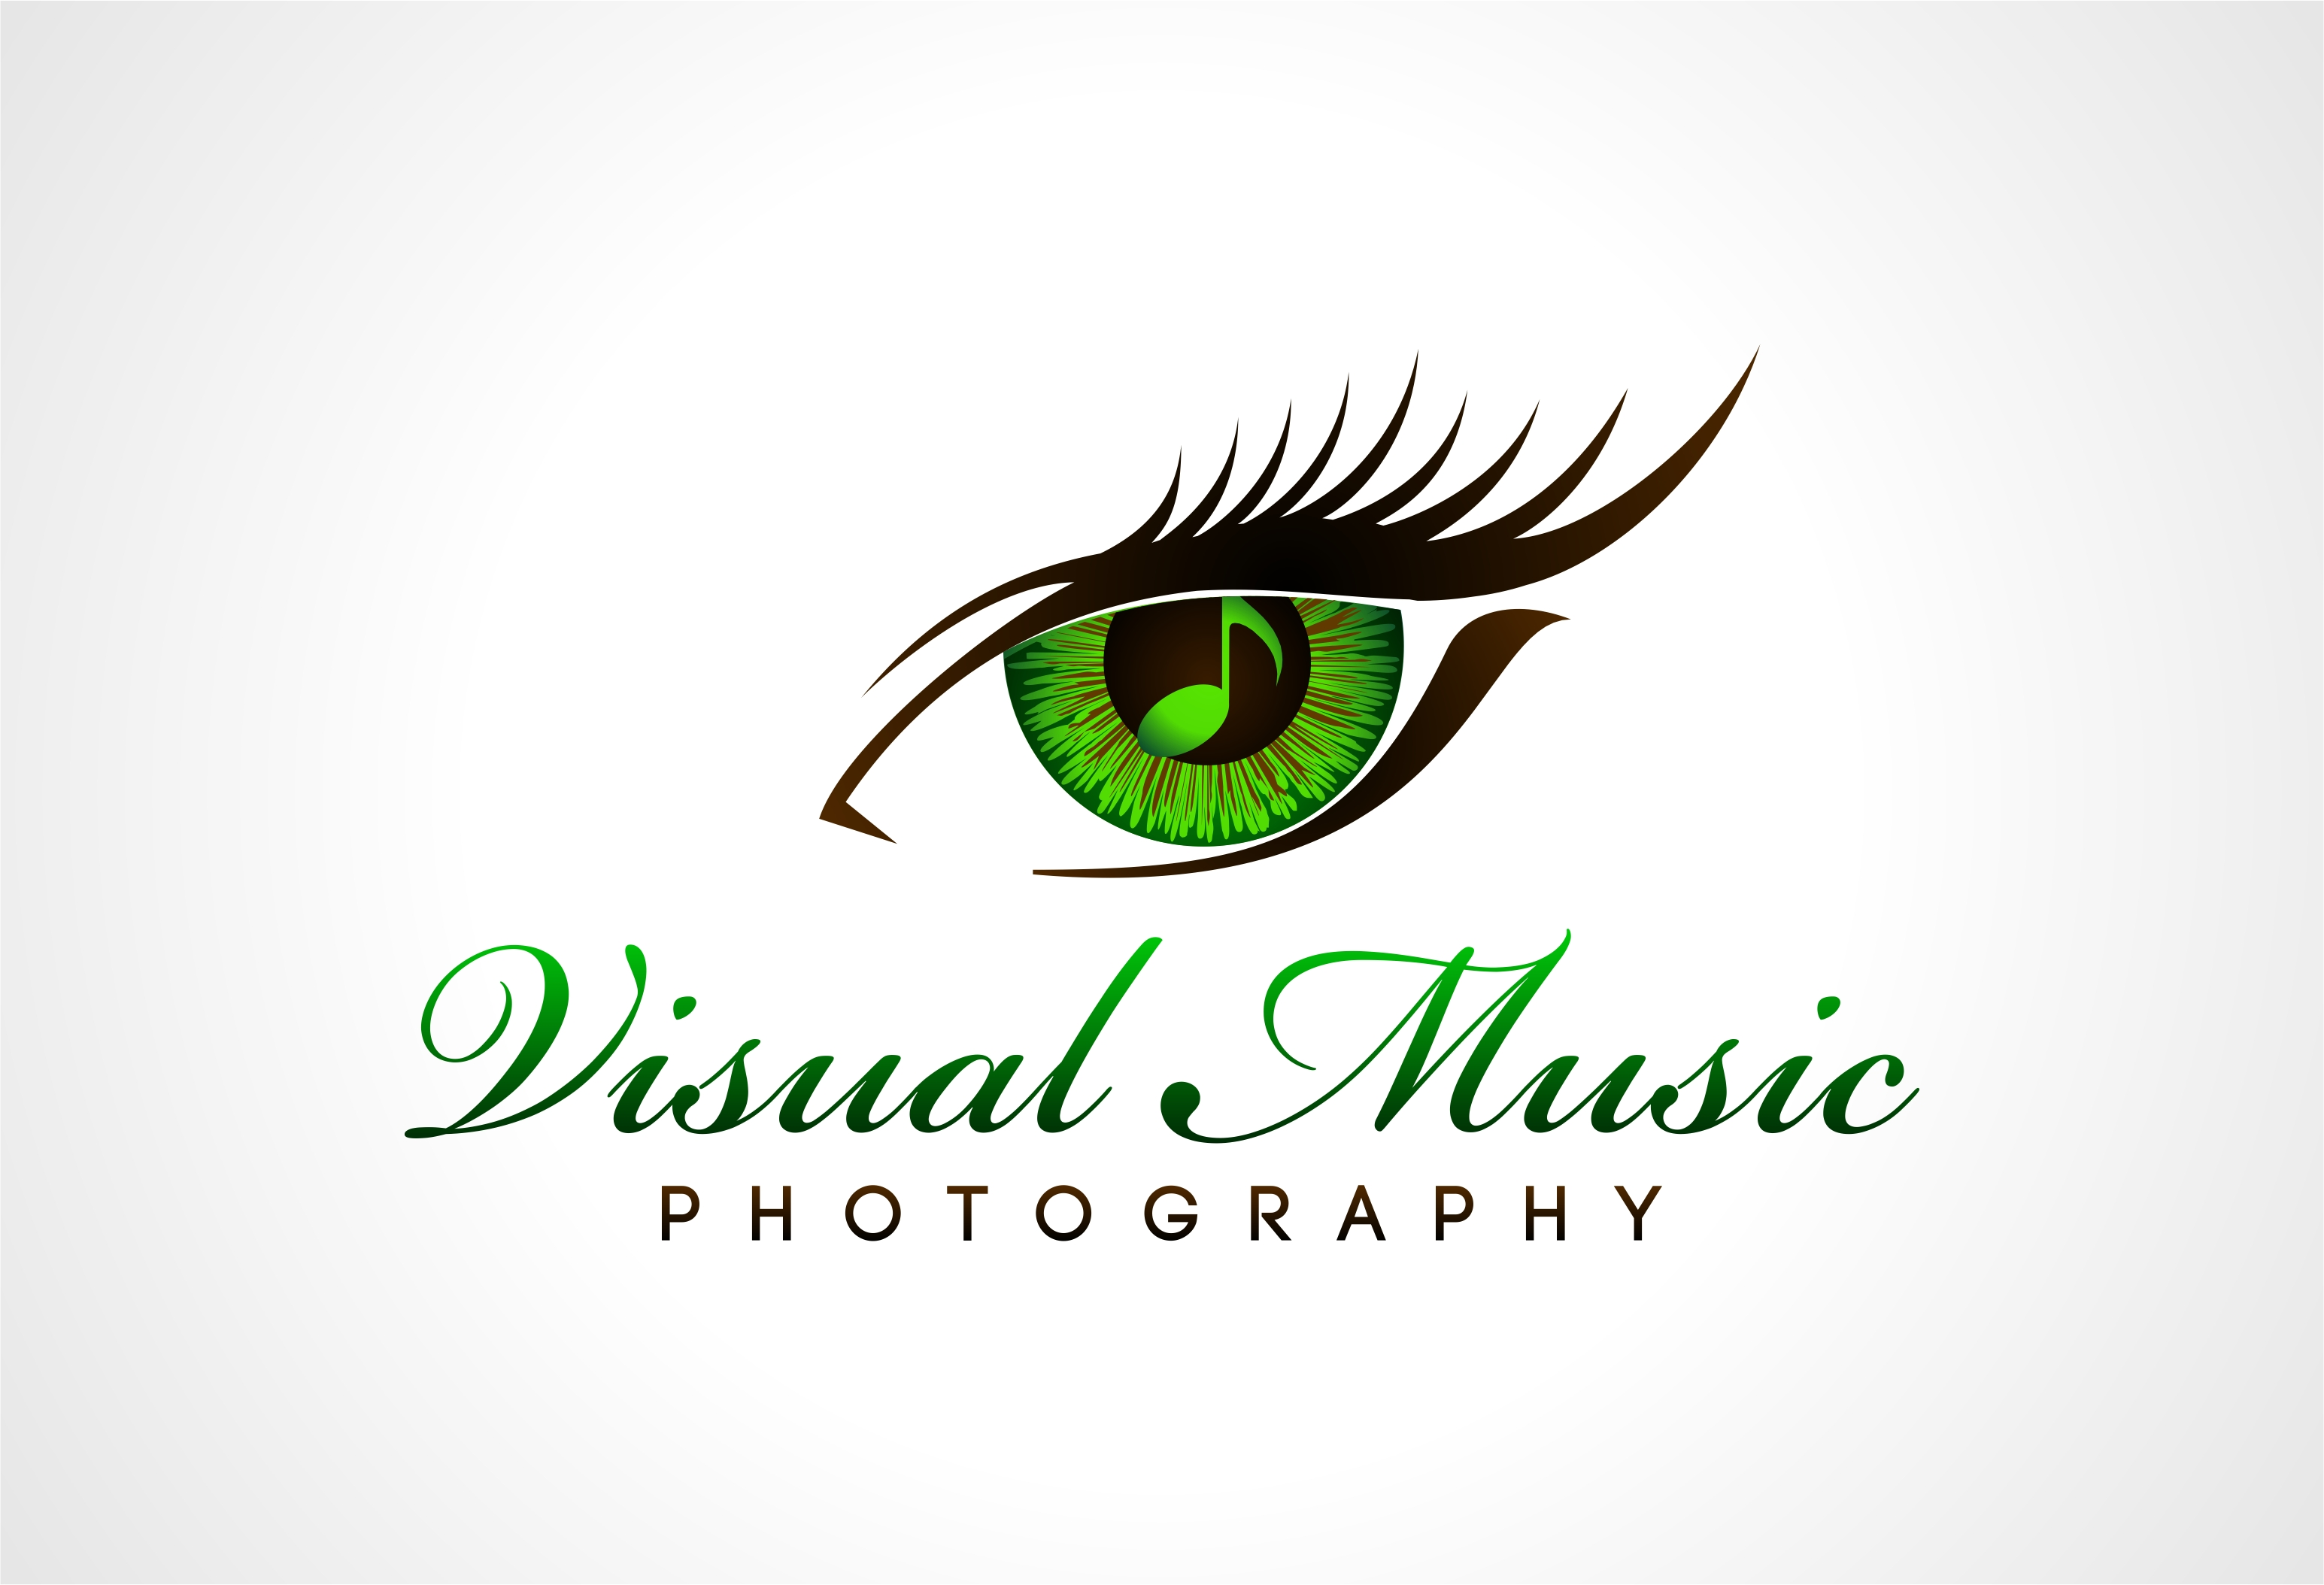
Hello fellow artists!

If you’re in need of headshots, look no more!
I am happy to take phone or in-person
consultations to discuss your goals and help
prepare you for a great shoot. Pricing listed
below.

I look forward to working with you!
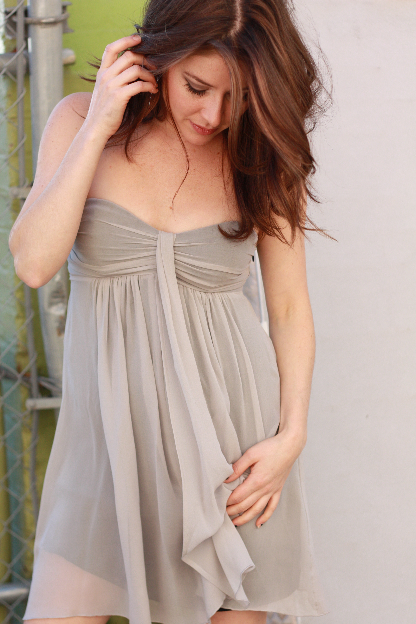
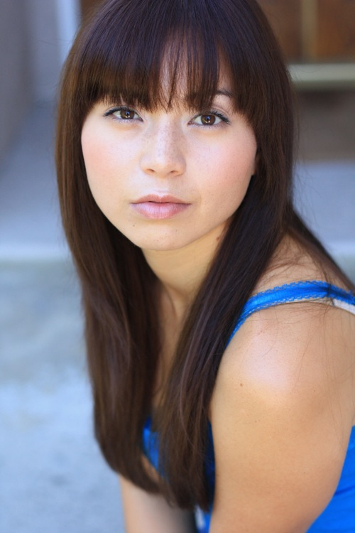
Elizabeth Keener
visualmusicphoto@gmail.com
770-655-6764

Adult Headshots $275
-2/3 looks
-DVD with all images
-One color corrected image for printing

Kids Headshots $215 (17 and under)
-2/3 looks
-DVD with all images
-One color corrected image for printing
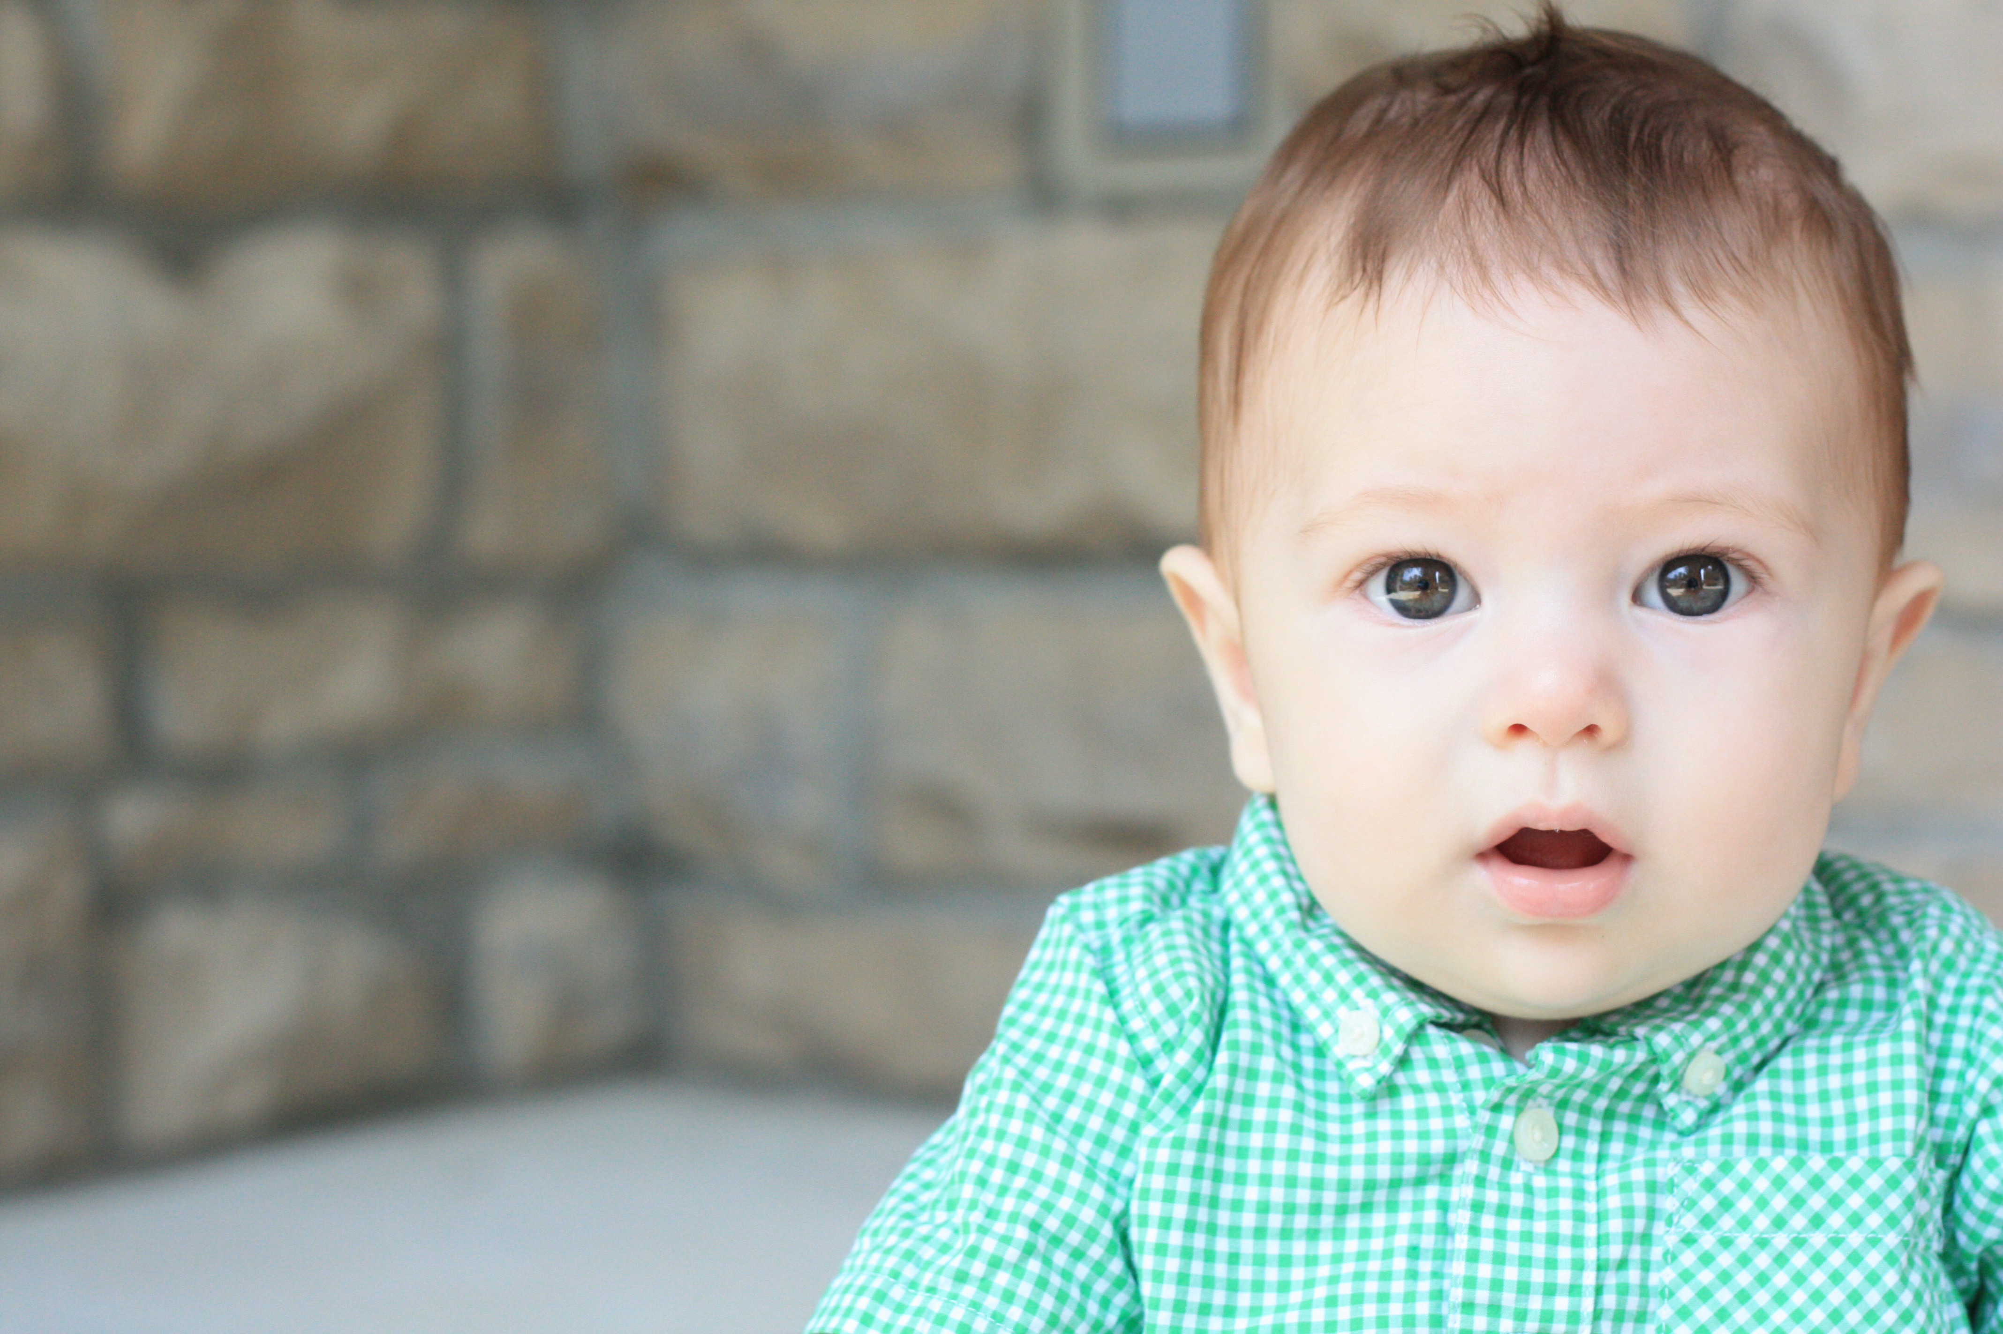
***Additional corrected images are $25.00 each
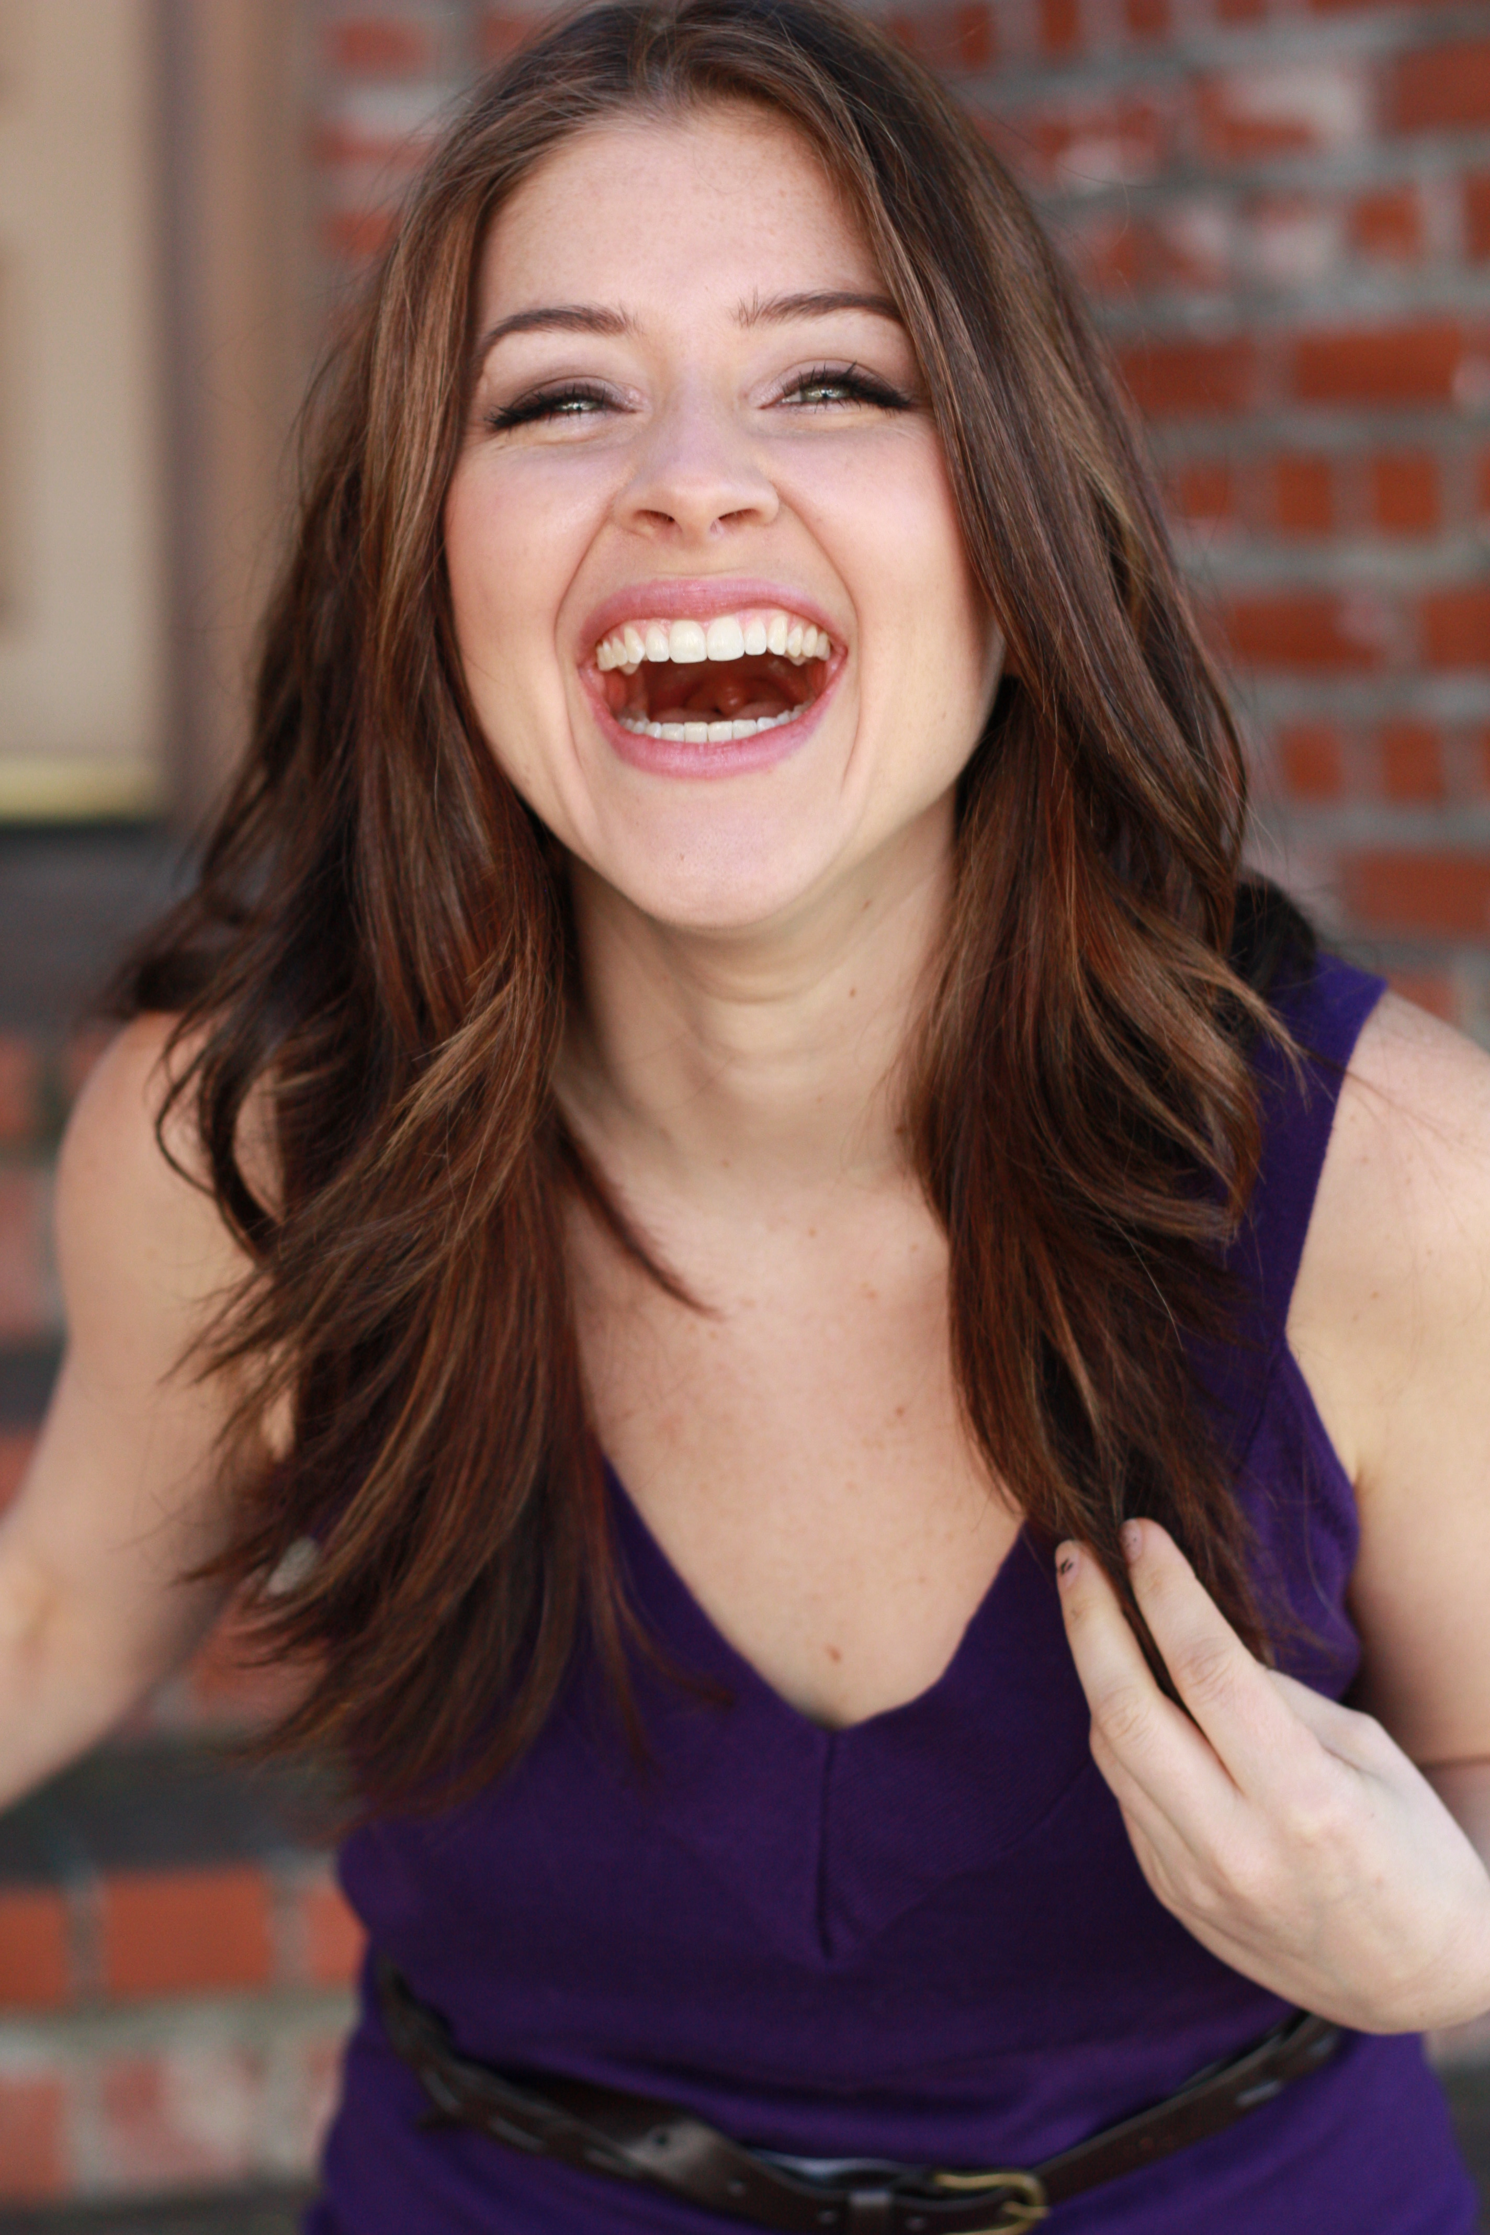
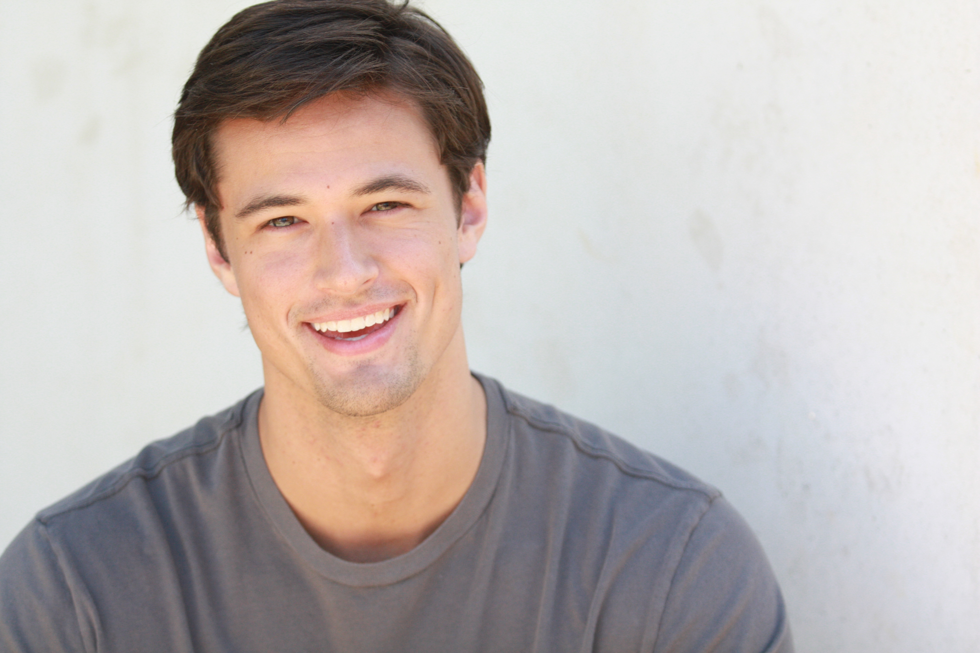
***Hair and Makeup artist available upon request

